ASSIGNMENT 1
Introduction to Web Development
1. Explain the difference between frontend, backend, and full-stack development with suitable real-world examples.
ANSWER 1 :
Frontend Development | Backend Development | Full-Stack Development
Frontend is the part of a website that users can see and interact with. | Backend is the part that works behind the scenes and handles data processing and business logic. | Full-stack development includes both frontend and backend development.
Uses HTML, CSS, JavaScript, React, Angular, etc. | Uses Node.js, Java, Python, PHP, .NET, etc. | Uses both frontend and backend technologies.
Focuses on user interface (UI) and user experience (UX). | Focuses on server, database, APIs, and security. | Handles complete web application development.

2. Create a simple diagram showing how the client-server model works in web architecture.
ANSWER 2 :
Client (Browser)
│
HTTP Request
│
▼
Web Server
│
Process Request
│
▼
Database
│
Return Data
│
▼
Web Server
│
HTTP Response
│
▼
Client (Browser)

3. Describe how a browser requests and displays a web page from a web server.

ANSWER 3 :
Steps:
1 : User enters a website URL (e.g., www.example.com).
2 : Browser sends an HTTP/HTTPS request to the web server.
3 : The server receives the request.
4 : If needed, the server retrieves data from the database.
5 : The server sends HTML, CSS, JavaScript, and other resources back to the browser.
6 : The browser downloads these files.
7 : The rendering engine converts HTML and CSS into a visual page.
8 : JavaScript is executed to make the page interactive.
9 : The complete webpage is displayed to the user.

4. Identify and list the tools required to set up a web development environment. Explain the purpose of each.

ANSWER 4 :
Tool | Purpose

Visual Studio Code (VS Code) | Code editor for writing HTML, CSS, JavaScript, and other languages.

Web Browser (Chrome, Firefox, Edge) | Tests and displays websites.

Git | Tracks code changes and version history.

GitHub | Stores code online and supports collaboration.

Node.js | Runs JavaScript outside the browser and installs packages.

npm | Package manager for installing libraries and frameworks.

Live Server Extension | Automatically refreshes the browser during development.

Developer Tools | Helps debug HTML, CSS, JavaScript, and network requests.
5. Explain what a web server is and give examples of commonly used servers.
ANSWER 5 :
A web server is software (or the computer running it) that receives requests from clients (browsers) and sends web pages or other resources back over HTTP or HTTPS.
Examples
- Apache HTTP Server
- Nginx
- Microsoft IIS (Internet Information Services)
- LiteSpeed
6. Define the roles of a Frontend Developer, Backend Developer, and Database Administrator in a project.
ANSWER 6 :
Frontend Developer
- Designs the user interface.
- Writes HTML, CSS, and JavaScript.
- Ensures responsive and attractive webpages.
Backend Developer
- Creates server-side logic.
- Develops APIs.
- Handles authentication and business logic.
- Connects applications with databases.
Database Administrator (DBA)
- Designs database structure.
- Manages data storage.
- Creates backups and restores data.
7. Install VS Code and configure it for HTML, CSS, and JavaScript development. Take a screenshot of the setup.
ANSWER 7 :
Steps
- Download and install Visual Studio Code.
- Open VS Code.
- Install these extensions:
  - Live Server
  - Prettier
  - HTML CSS Support
  - JavaScript (ES6) Code Snippets
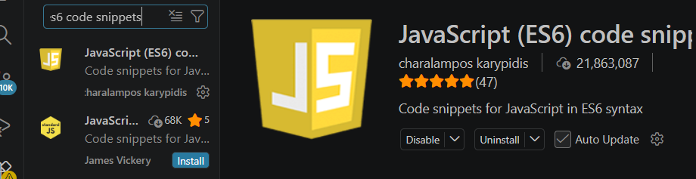
- Create a project folder.
- Create files:
  - index.html
  - style.css
  - script.js
- Right-click index.html.
- Select Open with Live Server.
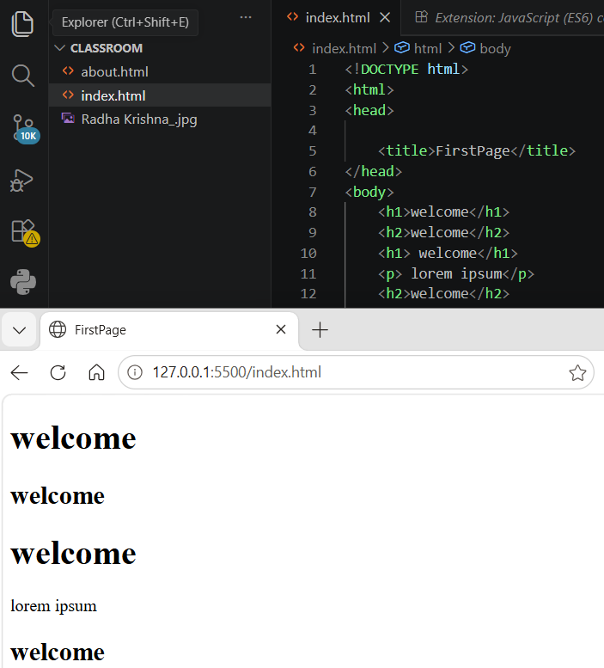
- Explain the difference between static and dynamic websites. Provide an example of each.
ANSWER 8 :
Static Website | Dynamic Website
Displays the same content to every user. | Content changes based on user actions or database data.
Built using HTML and CSS. | Uses HTML, CSS, JavaScript, backend languages, and databases.
Faster and simpler. | More interactive and feature-rich.
No database required. | Usually connected to a database.
Examples
Static Website:
- Personal portfolio
- Company brochure website
Dynamic Website:
- Facebook
- Amazon
- Instagram
- Online banking websites
- Research and list five web browsers. Explain how rendering engines differ between them.
ANSWER 9 :
Browser | Rendering Engine
Google Chrome | Blink
Microsoft Edge | Blink
Mozilla Firefox | Gecko
Apple Safari | WebKit
Opera | Blink
Difference Between Rendering Engines
A rendering engine interprets HTML, CSS, and JavaScript and displays the webpage on the screen.
- Blink (Chrome, Edge, Opera): Fast performance and widely compatible.
- Gecko (Firefox): Open-source engine focused on standards compliance and privacy.
- WebKit (Safari): Optimized for Apple devices with efficient performance and power usage.
Although browsers may display most websites similarly, rendering engines can differ in speed, optimization, support for new web features, and how they implement web standards.
- Draw a labeled diagram showing the basic web architecture flow — Client, Server, Database, and APIs
ANSWER 10 :
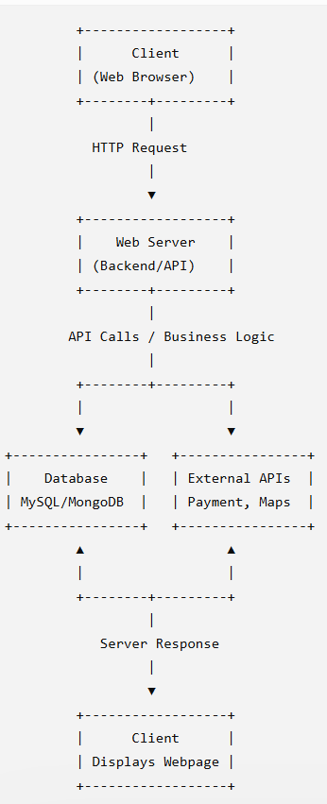

Name : Ayushi
Branch : B.Tech (CSE)
Roll no : 2415000424 (18)
Assignment 1

